

Practices for Secure Software Report

Table of Contents
Document Revision History 3
Client 3
Instructions 3
Developer 4
1. Algorithm Cipher 4
2. Certificate Generation 4
3. Deploy Cipher 4
4. Secure Communications 4
5. Secondary Testing 4
6. Functional Testing 4
7. Summary 4
8. Industry Standard Best Practices 4

Document Revision History

Version | Date | Author | Comments
1.0 | 02/21/2026 | Eric Burton | Implemented SHA-256 algorithm cipher explanation, generated and exported self-signed certificate, and included screenshots demonstrating checksum verification, HTTPS secure communication, dependency-check results, and refactored application code. Completed summary and documented industry standard secure coding practices.

Client



Instructions

Submit this completed practices for secure software report. Replace the bracketed text with the relevant information. You must document your process for writing secure communications and refactoring code that complies with software security testing protocols.

- Respond to the steps outlined below and include your findings.
- Respond using your own words. You may also choose to include images or supporting materials. If you include them, make certain to insert them in all the relevant locations in the document.
- Refer to the Project Two Guidelines and Rubric for more detailed instructions about each section of the template.

Developer
Eric Burton

Algorithm Cipher

SHA-256 was selected as the cryptographic checksum algorithm for Artemis Financial's file/data verification step. SHA-256 is a cryptographic hash function (SHA-2 family) that produces a fixed-length 256-bit digest, commonly represented as a 64-character hexadecimal string. In this project, SHA-256 is used for integrity verification (checksum), not for encrypting data. SHA-256 was chosen for Artemis Financial because it provides strong integrity verification for financial data transfer and is recommended by modern security standards for checksum validation (NIST, 2024).
Hash functions map input data of any size to a fixed-size output. SHA-256 is deterministic (same input yields the same hash), one-way (the original input cannot feasibly be reconstructed from the hash), and collision resistant (it is computationally infeasible to find two different inputs with the same hash) (NIST, 2024). These properties make SHA-256 an appropriate choice for checksum verification, because any change to the data results in a different hash.
Unlike encryption algorithms, SHA-256 does not use random numbers or keys. This differs from encryption ciphers that protect confidentiality. Symmetric encryption algorithms, such as AES, use a shared secret key to encrypt and decrypt data, while asymmetric encryption algorithms, such as RSA, use a public and private key pair and are commonly used for certificates and secure communication (Manico & Detlefsen, 2014). In this project, asymmetric cryptography is used in the self-signed certificate to enable TLS for HTTPS communication, while SHA-256 provides data integrity verification through checksum generation. When used together, TLS encryption protects data in transit while SHA-256 ensures that transferred data has not been altered, providing multiple layers of security.
Historically, cryptographic hashing algorithms have evolved as older methods became vulnerable to attacks. Earlier algorithms such as MD5 and SHA-1 are no longer recommended for security-sensitive applications due to known collision vulnerabilities (NIST, 2024). SHA-256 remains a widely accepted modern standard for secure integrity verification and is commonly used in secure protocols, digital signatures, and web applications. The development of modern cryptography reflects the ongoing need to protect data confidentiality, integrity, and authenticity in networked systems (Schneider, n.d.).

SHA-256 remains computationally secure because no practical collision attacks currently exist, making it suitable for modern integrity verification in financial applications.

Certificate Generation
Insert a screenshot below of the CER file.

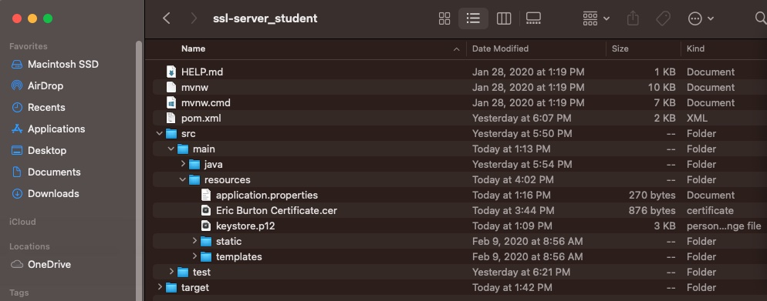

Deploy Cipher
Insert a screenshot below of the checksum verification.
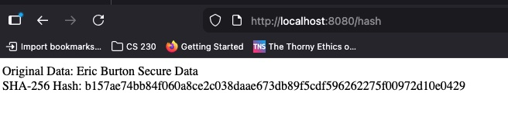

Secure Communications
Insert a screenshot below of the web browser that shows a secure webpage.

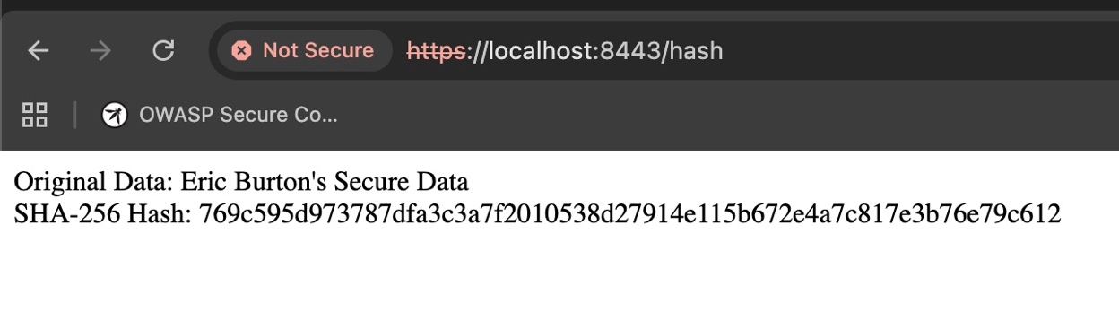

Secondary Testing
Insert screenshots below of the refactored code executed without errors and the dependency-check report.

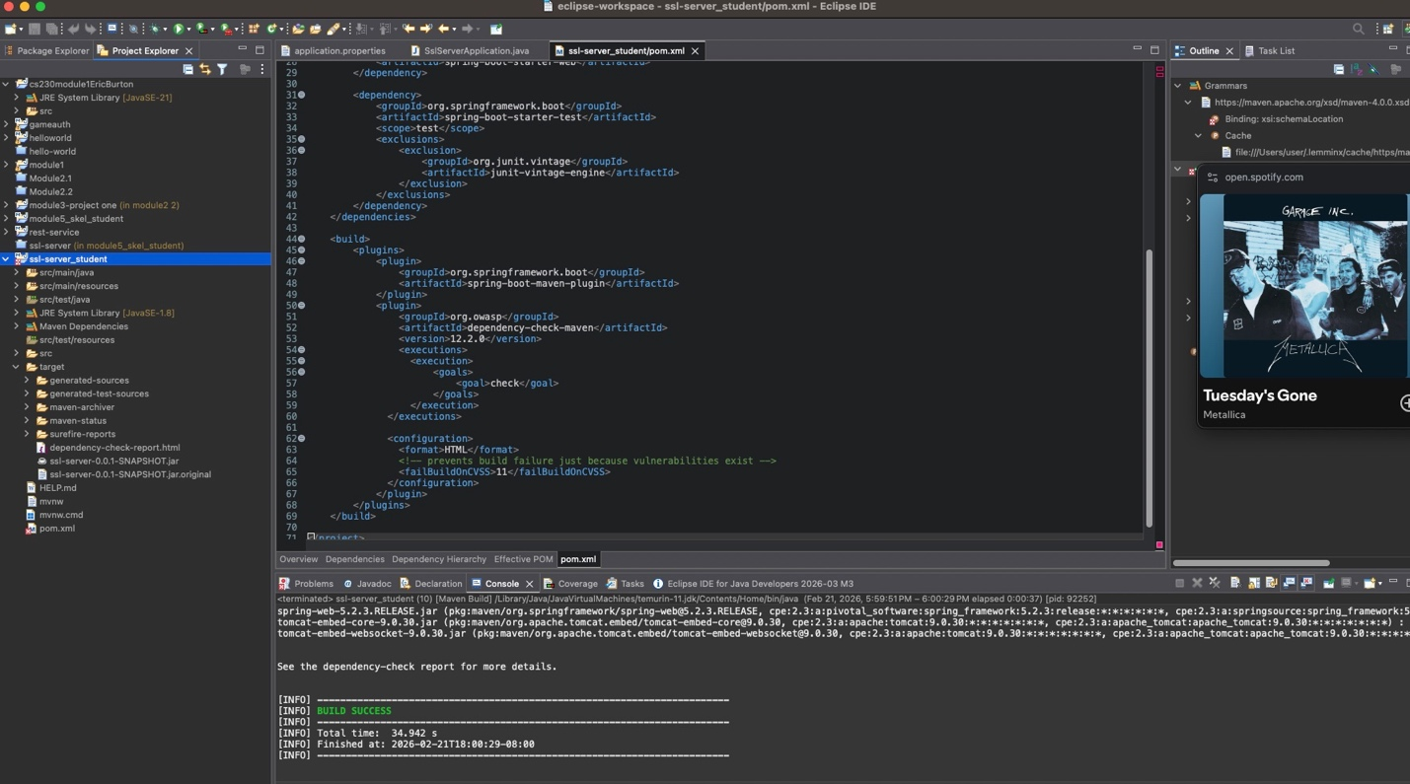

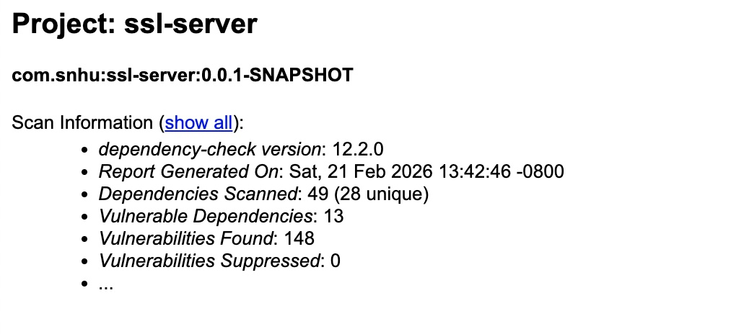

Functional Testing
Insert a screenshot below of the refactored code executed without errors.

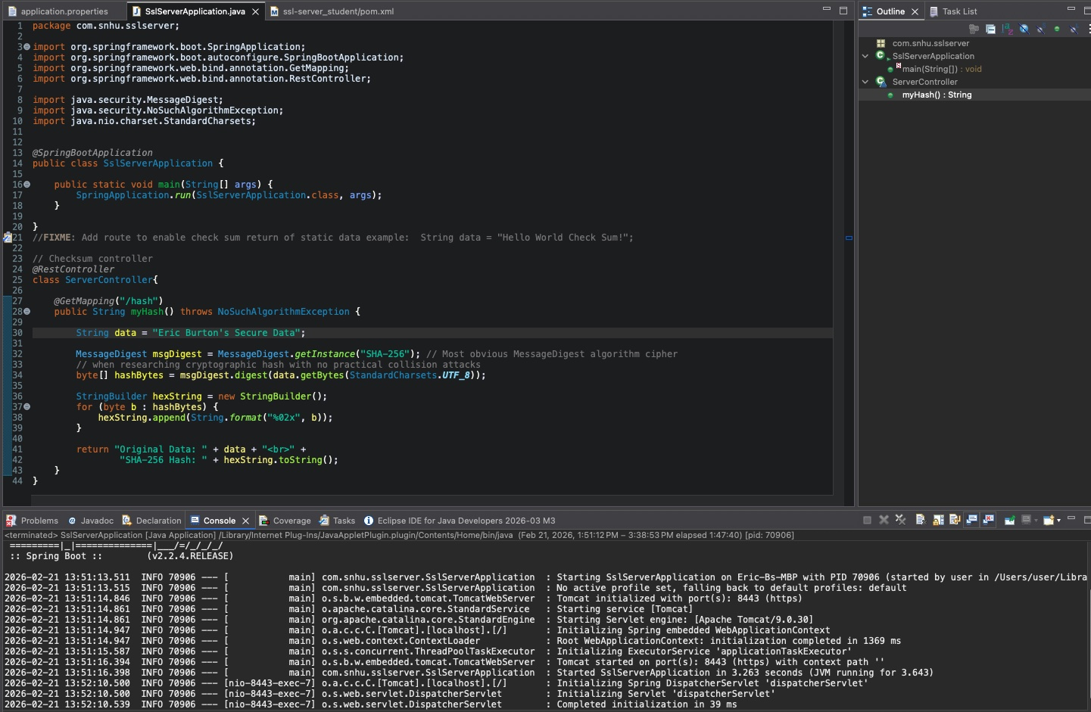

Summary

This project refactored the Artemis Financial Spring Boot application to add layered security controls and to comply with secure software testing protocols. The refactor added an integrity verification step by generating a SHA-256 checksum for a static, unique data string via the /hash endpoint. In addition, secure communications were enabled by configuring HTTPS (TLS) on port 8443 using a PKCS12 keystore. The refactoring process followed a layered security approach by implementing cryptographic hashing, secure HTTPS communication, and vulnerability testing. These practices align with secure software development principles that emphasize protecting data integrity, confidentiality, and system reliability (Manico & Detlefsen, 2014).

Using the vulnerability assessment process flow, several security areas were addressed.
Cryptography was strengthened by implementing SHA-256 hashing and configuring TLS through a self-signed certificate. Client-server communication was secured by replacing HTTP with HTTPS.
Code quality and secure coding practices were improved through the use of Java’s MessageDigest class and verification of correct output formatting. Architecture review and testing were performed by establishing a baseline dependency scan, refactoring the code, and re-running static testing to confirm that no new vulnerabilities were introduced.

To add layers of security, the application now protects data in transit (TLS encryption) and provides integrity verification (SHA-256 checksum). Secondary static testing was performed using OWASP Dependency-Check before and after refactoring. The post-refactor scan showed no increase in vulnerability counts, indicating that the refactor did not introduce additional dependency risk. Functional testing was completed through manual code review and by executing the application to confirm it runs without errors and returns the expected checksum over HTTPS.

Industry Standard Best Practices

Industry standard best practices were applied throughout the refactoring process to maintain and enhance application security. Secure coding practices were followed to implement cryptographic hashing and secure communications, which help reduce the risk of data tampering and unauthorized access. Applying established secure development methods helps organizations protect sensitive data, maintain customer trust, and reduce potential financial or reputational damage caused by security breaches (Manico & Detlefsen, 2014). First, well-established cryptographic standards were used: SHA-256 for integrity verification and an RSA 2048-bit key pair for TLS certificate generation. Second, transport security was implemented by enabling HTTPS to encrypt client-server communication and reduce the risk of interception or tampering in transit.
To maintain existing security and avoid regression, OWASP Dependency-Check was executed as a static analysis control before and after refactoring. This provides ongoing visibility into third-party library risk and ensures that new changes do not introduce additional vulnerable dependencies. Manual functional review complemented static testing by checking the refactored code for syntax, logic, and secure handling.
Applying these best practices improves Artemis Financial's overall well-being by increasing customer trust, reducing the likelihood of data exposure, and establishing a repeatable process (scan -> refactor -> re-test) that supports secure development over time.

Following industry standards also supports regulatory compliance expectations for financial systems and promotes long-term maintainability of secure software.

References

Manico, J., & Detlefsen, A. (2014). Iron-clad Java: Proven methods for building secure java-based web applications. McGraw Hill Computing.
National Institute of Standards and Technology. (2024). Hash functions. National Institute of Standards and Technology. https://csrc.nist.gov/Projects/hash-functions
Schneider, J. (n.d.). A brief history of cryptography: Sending secret messages throughout time. IBM. https://www.ibm.com/think/topics/cryptography-history#542333542

